**Lembar Jawaban Kalkulasi Neural Network**

**Pada lembar jawaban ini, kamu dapat menuliskan cara mengkalkulasikan nilai-nilai yang diminta pada arsitektur neural network sesuai soal beserta hasilnya, ya, semangat!😄**

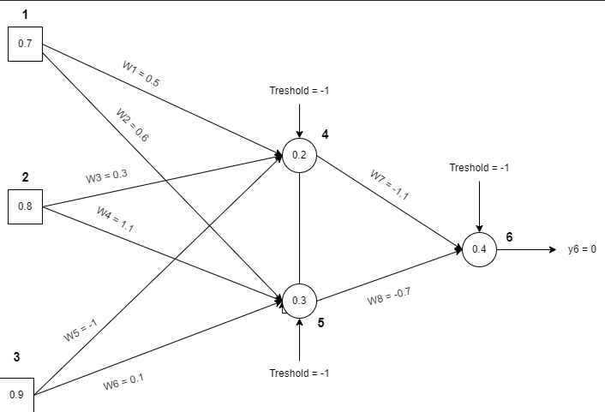

Pertama, masukkan dulu nilai initial value dan initial randomnya ya …

**Initial Value**

|  |  |  |  |  |  |
| --- | --- | --- | --- | --- | --- |
| **x1** | **x2** | **x3** | **α** | **Threshold** | **Yd,6** |
| 0.7 | 0.8 | 0.9 | 0.1 | -1 | 0 |

**Initial Random**

|  |  |  |  |  |  |  |  |  |  |  |
| --- | --- | --- | --- | --- | --- | --- | --- | --- | --- | --- |
| **W14** | **W15** | **W24** | **W25** | **W34** | **W35** | **W46** | **W56** | **θ4** | **θ5** | **θ6** |
| 0.5 | 0.6 | 0.3 | 1.1 | -1 | 0.1 | -1.1 | -0.7 | 0.2 | 0.3 | 0.4 |

Jika sudah selesai, kita akan masuk ke langkah-langkah kalkulasi, sebagai berikut:

**Forward Pass**

Forward Pass merupakan hasil dari langkah 1 pada proses kalkulasi di challenge deck. Oleh karena itu kamu tuliskan langkah kalkulasi yang kamu lakukan untuk mencari nilai-nilai di bawah ini, ya🙌

**Langkah 1: Menghitung output Neuron 4 (y4), Neuron 5 (y5), Neuron 6 (y6), dan Error menggunakan sigmoid function**

|  |  |
| --- | --- |
| Y4 | = |
|  | = |
|  | = |
| Y5 | = |
|  | = |
|  | = |
| Y6 | = |
|  | = |
|  | = |
| e | = |
|  | = |
|  | = |

Lalu isi rangkuman hasilnya di tabel ini ya …

|  |  |  |  |
| --- | --- | --- | --- |
| **Y4** | **Y5** | **Y6** | **e** |
|  |  |  |  |

**Backward Pass**

Sementara itu, nilai-nilai dari backward pass didapatkan dengan menjalankan langkah 2, 3, dan 4. Jangan lupa tuliskan proses dan hasil kalkulasinya pada tempat yang telah disediakan di bawah, ya👍

**Langkah 2: Hitung error gradient untuk Neuron 6 di Output Layer dan weight corrections**

|  |  |
| --- | --- |
| $$δ6$$ | = $y_{6}\left(1-y_{6}\right)e$ |
|  | = $0.208073025(1-0.208073025)×(-0.208073025)$ |
|  | = $0.03428599$ |
| $$∆w_{46}$$ | = $α×y_{4}×δ_{6}$ |
|  | = $0.1×0.375193526×0.03428599$ |
|  | = $0.001286388$ |
| $$∆w_{56}$$ | = $α×y_{5}×δ_{6}$ |
|  | = $0.1×0.748381722×0.03428599$ |
|  | = $0.002565901$ |
| $$∆θ_{6}$$ | = $α×\left(-1\right)δ_{6}$ |
|  | = $0.1×(-1)×0.03428599$ |
|  | = $-0.003428599$ |

Lalu isi rangkuman hasilnya di tabel ini ya …

|  |  |  |  |
| --- | --- | --- | --- |
| **δ6** | **∇46** | **∇56** | **∇θ6** |
|  |  |  |  |

**Langkah 3: Hitung error gradients untuk Neuron 4 dan Neuron 5 di Middle Layer/Hidden Layer**

|  |  |
| --- | --- |
| δ4 | = |
|  | = |
|  | = |
| δ5 | = |
|  | = |
|  | = |

Lalu isi rangkuman hasilnya di tabel ini ya …

|  |  |
| --- | --- |
| **δ4** | **δ5** |
|  |  |

**Langkah 4: Hitung weight corrections dengan asumsi parameter learning rate adalah 0.1**

|  |  |
| --- | --- |
| ${∆w}_{14}$ | = $α ×x_{1}×δ_{4}$ |
|  | = $0.1×0.7×(-0.00884118)$ |
|  | = $-0.000618883$ |
| $${∆w}_{24}$$ | = $α ×x_{2}×δ_{4}$ |
|  | = $0.1×0.8×(-0.00884118)$ |
|  | = $-0.000707294$ |
| $$∆w_{34}$$ | = $α ×x_{3}×δ_{4}$ |
|  | = $0.1×0.9×(-0.00884118)$ |
|  | = $-0.000795706$ |
| $${∆θ}_{4}$$ | = $α ×(-1)×δ_{4}$ |
|  | = $0.1×(-1)×(-0.00884118)$ |
|  | = $0.000884118$ |
| $$∆w_{15}$$ | = $α ×x_{1}×δ_{5}$ |
|  | = $0.1×0.7×(-0.004519393)$ |
|  | = $-0.000316358$ |
| $∆w_{25}$ | = $α ×x_{2}×δ_{5}$ |
|  | = $0.1×0.8×(-0.004519393)$ |
|  | = $-0.000361551$ |
| $$∆w_{35}$$ | = $α ×x_{3}×δ_{5}$ |
|  | = $0.1×0.9×(-0.004519393)$ |
|  | = $-0.000406745$ |
| $$∆θ_{5}$$ | = $α ×(-1)×δ_{5}$ |
|  | = $0.1×(-1)×(-0.004519393)$ |
|  | = $0.000451939$ |

Lalu isi rangkuman hasilnya di tabel ini ya …

|  |  |  |  |  |  |  |  |
| --- | --- | --- | --- | --- | --- | --- | --- |
| **∇w14** | **∇w24** | **∇w34** | **∇θ4** | **∇w15** | **∇w25** | **∇w35** | **∇θ5** |
| -0.000618883 | -0.000707294 | -0.000795706 | 0.000884118 | -0.000316358 | -0.000361551 | -0.000406745 | 0.000451939 |

**Backward Pass**

Last but not least, adalah nilai-nilai dari updated weight didapatkan dengan menjalankan langkah nomor 5. Seperti biasa, tuliskan proses dan hasil kalkulasinya pada tempat yang telah disediakan di bawah, ya👌

**Langkah 5: Hitung semua weights dan theta pada arsitektur yang telah diperbarui**

|  |  |
| --- | --- |
| w14 | = |
|  | = |
|  | = |
| w15 | = |
|  | = |
|  | = |
| w24 | = |
|  | = |
|  | = |
| w25 | = |
|  | = |
|  | = |
| w34 | = |
|  | = |
|  | = |
| w35 | = |
|  | = |
|  | = |
| θ4 | = |
|  | = |
|  | = |
| θ5 | = |
|  | = |
|  | = |
| θ6 | = |
|  | = |
|  | = |

Lalu isi rangkuman hasilnya di tabel ini ya …

|  |  |  |  |  |  |  |  |  |
| --- | --- | --- | --- | --- | --- | --- | --- | --- |
| **w14** | **w15** | **w24** | **w25** | **w34** | **w35** | **Θ4** | **Θ5** | **Θ6** |
| 0.499381117 | 0.599683642 | 0.299292706 | 1.099638449 | -1.000795706 | 0.099593255 | 0.200884118 | 0.300451939 | 0.396571401 |

**Hore, kamu sudah menyelesaikan satu dari tiga proyek challenge platinum! Semoga mendapatkan hasil yang maksimal dan selamat bersenang-senang~**